
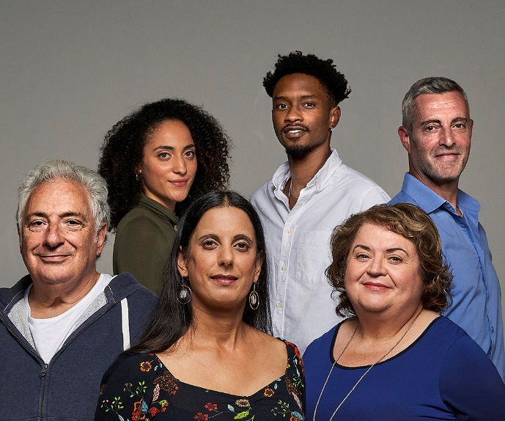



Scotland’s Census 2022

Microdata Teaching File

User Guide

August 2025

Contents
1. Introduction 3
2. Confidentiality and protection of personal data 3
3. 2022 Census Microdata Products 3
4. Purpose of the 2022 Census Microdata Teaching File 4
5. Sampling 4
6. How the Teaching File should be cited 5
Appendix 1: Contents of the Teaching File 5

Introduction

Scotland’s Census is the official count of every person and household in the country. There has been a census in Scotland every 10 years since 1801, except 1941. The 2021 census in Scotland was moved to 2022 due to the impact of the COVID-19 pandemic.

For the 2022 Census, National Records of Scotland (NRS) asked people to fill in a census questionnaire online or on paper, to reflect their circumstances on the 20th of March, 2022. The questionnaire included household questions about the address and its occupants, as well as individual questions about each person staying at the address.

Census statistics are used to help understand the increasingly diverse nature of Scotland’s population by capturing the similarities and differences in the populations' characteristics locally and nationally. The census provides a rich source of data to learn about our population and are used for research and teaching purposes.

NRS published standard output tables containing summary statistics that describe the characteristics of Scotland’s population. However, these tables do not always provide the flexibility needed for specific research questions to be answered. In order to make census data more accessible for research purposes, NRS is producing a number of microdata products based on a sample of anonymised census data at an individual person and household level.

Confidentiality and protection of personal data

By law we keep personal census details confidential for 100 years. Until then, we will not share or publish information that would reveal personal information.

We use statistical techniques to ensure that the risk of disclosure of personal information is minimised. The Scotland’s census website includes a description of the principles of the Statistical Disclosure Control (SDC) methodology applied to the 2022 census. We ensure that microdata products remain anonymised and confidential in line with other census products.

2022 Census Microdata Products

The Teaching File is a sample of 54,399 records (approximately 1 per cent) relating to people living (usually resident) in Scotland at the time of the 2022 Census. For each individual, information is available for 15 separate characteristics (e.g. age, sex marital status) to varying degrees of detail. Further information on the categories available in the Teaching File for each characteristic is provided in Appendix 1, and additional background on definitions is available on our website.

The Teaching File is a comma separated format text file (.csv) and is available to everyone subject to Crown Copyright protection (see section 6).

Equivalent Teaching Files for England and Wales have been published by the Office for National Statistics (ONS).

In addition to the Teaching File, NRS will publish two further 2022 Census microdata products that will be available under controlled access arrangements, as detailed below:

- Secure extract: An anonymised 10% sample of individuals and an anonymised 10% sample of households. These samples will not overlap. They will be available through application to the ONS Secure Researcher Service.

- Safeguarded extract: Two anonymised 5% samples of individuals are available to approved researchers through the UK Data Service, one at Scotland level and one at Grouped Local Area level. These samples are non-overlapping and were drawn from the 10 per cent secure individual sample mentioned above. The safeguarded products contain a reduced level of detail compared with the secure sample.

Purpose of the 2022 Census Microdata Teaching File

The primary purpose of the Teaching File is as an educational tool aimed at:

- assisting with the teaching of statistics and geography in schools and education establishments;
- providing an introduction to the detail, available in microdata products in order to give users the skills and information necessary to make use of the more detailed products to come;
- encouraging wider use of census data by providing a way of examining census data beyond the standard tables.

Due to the relatively small sample size and limited detail available for each of the characteristics included, the Teaching File may not always be the most appropriate data set for analysis. For example:

- When considering the population of Scotland as a whole, it is always more appropriate to use a published table that includes the entire population.
- In some cases, it may be preferable to use more detailed classifications available from standard Census tables, the Scotland’s census 2022 Flexible Table Builder, or (once available) the secure/safeguarded Census microdata products. For example, if the research question examines differences between those aged 18 and over and those aged under 18, it would be better to use data with single-year-of-age breakdowns rather than the 16–24 age grouping available in the Teaching File.

If detailed multivariate analysis is required, then the small sample size of the Teaching File may result in reduced reliability for any conclusions drawn. If detailed multivariate analysis is required, then consideration should be given to further collapsing categories or using the secure/safeguarded microdata products with their larger sample sizes.

Sampling

A random 1 per cent sample of individual person records was selected from the complete 2022 Census dataset. The distribution of each variable was compared to the distribution of the complete 2022 Census to make sure that the Teaching File is representative of the population. As this is a sample, it is subject to sampling error, which arises whenever variable estimates are based on a sample rather than a full census of the population. Care should be taken when generalising findings from any sample to a wider population.

How the Teaching File should be cited

All material on the NRS website is covered by Crown Copyright protection unless otherwise stated.

Information in the Teaching File (not including logos) can be reproduced or adapted freely without a specific application for a licence under the terms of the Open Government Licence as long as the source is acknowledged. If you reproduce the information then you have to include the following source accreditation: National Records of Scotland licensed under the Open Government Licence. If you adapt the information you have to include the following source accreditation: Adapted from data from National Records of Scotland licensed under the Open Government Licence.

Appendix 1: Contents of the Teaching File

Variable Name | Number of  Categories | Variable  Values
Age | 8 | 1. 0 to 15  2. 16 to 24  3. 25 to 34  4. 35 to 44  5. 45 to 54  6. 55 to 64  7. 65 to 74  8. 75 and over
Approximate_Social_Grade | 4 (also -5) | 1. AB  2. C1  3. C2  4. DE  -5. No code required (People aged under 16 and people resident in communal establishments)
Country_Of_Birth | 2 | 1. UK  2. Non UK
Economic_Activity | 9 (also -5) | 1. Economically active: Employed  2. Economically active: Self-Employed  3. Economically active: Unemployed  4. Economically active: Full-time student  5. Economically inactive: Retired  6. Economically inactive: Student  7. Economically inactive: Looking after home or family  8. Economically inactive: Long-term sick or disabled  9. Economically inactive: Other  -5. No code required (Aged under 16)
Ethnic_Group | 5 | 1. White  2. Mixed or multiple ethnic group  3. Asian  4. African  5. Caribbean or black  6. Other ethnic group
Family_Composition | 6 (also -5) | 0. Not in a family  1. Married/same-sex civil partnership couple family  2. Cohabiting couple family  3. Lone parent family (male head)  4. Lone parent family (female lead)  5. Other related family  -5. No code required (residents of a communal establishment)
Health (General health) | 5 | 1. Very good health  2. Good health  3. Fair health  4. Bad health  5. Very bad health
Hours_Worked_Per_Week | 4 (also -5) | 1. Part-time: 15 or less hours worked  2. Part-time: 16 to 30 hours worked  3. Full-time: 31 to 48 hours worked  4. Full-time 49 or more hours worked  -5. No code required (People aged under 16 and people not working)
Industry | 13 (also -5) | 1. Agriculture, forestry and fishing  2. Mining and quarrying; Manufacturing; Electricity, gas, steam and air conditioning system; Water supply  3. Construction  4. Wholesale and retail trade; Repair of motor vehicles and motorcycles  5. Accommodation and food service activities  6. Transport and storage; Information and communication  7. Financial and insurance activities  8. Real estate activities; Professional scientific and technical activities; Administrative and support service activities  9. Public administration and defence  10. Education  11. Human health and social work activities  12. Arts; entertainment and recreation  13. Other  -5. No code required (People aged under 16 and people who have never worked)
Marital_Status | 5 (also -5) | 1. Single (Never married or never registered a same-sex civil partnership  2. Married or in a same sex-civil partnership  3. Separated, but still legally married or still legally in a same-sex civil partnership  4. Divorced or formerly in a same-sex civil partnership which is now legally dissolved  5. Widowed or surviving partner from a same-sex civil partnership  -5. No code required (comprises persons aged under 16 and schoolchildren and full-time students)
Occupation | 9 (also -5) | 1. Managers, Directors and Senior Officials  2. Professional Occupations  3. Associate Professional and Technical Occupations  4. Administrative and Secretarial Occupations  5. Skilled Trades Occupations  6. Caring, Leisure and Other Service Occupations  7. Sales and Customer Service Occupations  8. Process, Plant and Machine Operatives  9. Elementary Occupations  -5. No code required (People aged under 16 and people who have never worked)
Record_Number | Unique reference ID | Unique reference ID
Region | 1 | S92000003 - Scotland
Religion | 9 | 1. No religion  2. Christian  3. Buddhist  4. Hindu  5. Jewish  6. Muslim  7. Sikh  8. Other religion  9. Not stated
Residence_Type | 2 | C. Resident in a Communal Establishment  H. Not resident in a Communal Establishment
Sex | 2 | 1. Male  2. Female
Student  (Schoolchild or full-time student) | 2 | 1. Yes  2. No

