Scotland’s Census 2022
Partner Social Media
Suggested Posts
From April 2022

How to use this content
Thank you so much for supporting Scotland’s Census campaign. Your support is helping us reach as many people as possible across Scotland, and ensure their voices are heard.

In the Images/Videos column you will find links to images sized for Facebook, Twitter, and Instagram. There are a range of images/videos and messages to choose from. Please choose an image/video and message you feel will resonate most with your audience, and post it with the below text to accompany.

Date to post | Platform | Post | Images /Videos
Option one | Facebook | It is a legal responsibility for every adult to complete #ScotlandsCensus2022 @Scotscensus2022. You could be fined if you don’t. Fill it in now at census.gov.scot  Scotland's Census. Getting the right things out starts with filling it in. | Select videos or statics from the links below  Scotland's Census 2022: final reminder promotional images | Scotland's Census (scotlandscensus.gov.uk)  Scotland's Census 2022: final reminder social media videos | Scotland's Census (scotlandscensus.gov.uk)  Many examples are available.
 | Twitter | It is a legal responsibility for every adult to complete #ScotlandsCensus2022 @Scotscensus2022. You could be fined if you don’t. Fill it in now at census.gov.scot  Scotland's Census. Getting the right things out starts with filling it in.
 | Instagram | It is a legal responsibility for every adult to complete #ScotlandsCensus2022 @Scotscensus2022. You could be fined if you don’t. Fill it in now at census.gov.scot  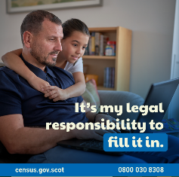  Scotland's Census. Getting the right things out starts with filling it in.

